**IFT598**

**Data Visualization & Reporting for IT**

**Professor Asmaa Elbadrawy**

**Group 19**

Niharika LNU

Sahil Sharma

Janak Sonalkar

**Project - Phase III: Dashboard Implementation**

24th April 2022

**Superstore Performance Analytics Dashboard**

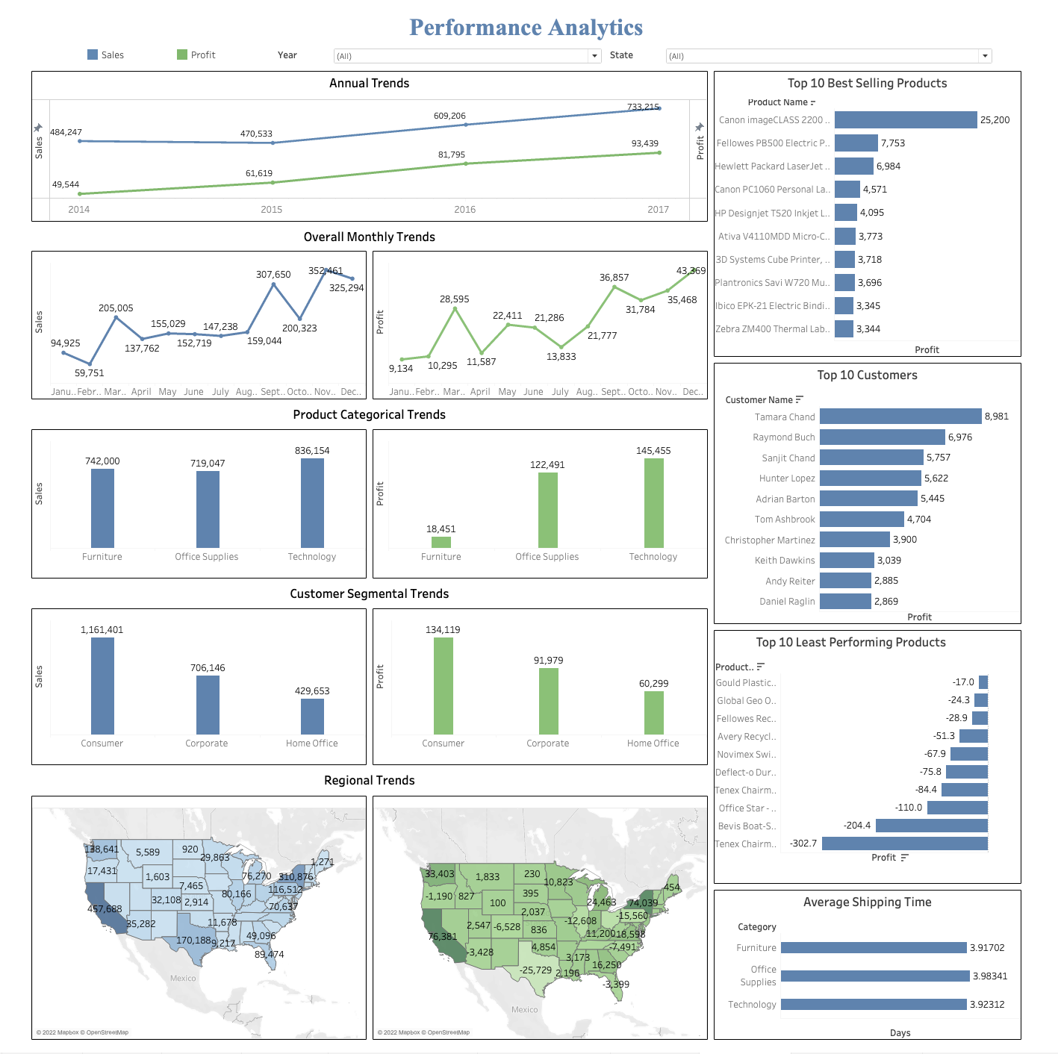

**Dashboard Description**

The superstore performance dashboard is a visualization of analyzed data that displays parameters that are important to the performance of the organization. To make it easier to grasp what this data means, it displays summary measurements as well as accompanying visualizations. This dashboard makes it simple to understand where the company stands at a glance. This dashboard contains data on sales, profitability, top 10 customers/best-selling/least selling products, and average shipping time of these products.

The following information is presented on the dashboard:

* Sales: Trend by location, by month/year, by average order value, by customer, and so on.
* Inventory: top-selling products, bottom selling products where items sell, who buys what, and so on.
* Profit: Trend by location, by month/year, by average order value, by customer, and so on
* Data is divided down by location, year, and state wise.

**Dataset**

**Superstore Dataset:** Retail dataset of a US based superstore over four years

* People buy everything from books, toys, clothes, and shoes to food, furniture, and other home things via an e-commerce platform. This data set is related to online shopping from a superstore.
* The Superstore dataset includes customers' order information for orders placed at a superstore in the United States.
* This comprises information such as the state, area, order date, shipment date, and product ordered, among other things.
* This is a small data collection of superstores in the United States from 2014 to 2018.

**Why Superstore Dataset**

* Over the years, online shopping has become increasingly popular due to its convenience, ease of use, and ability to bargain shop from the comfort of one's home or office. During a holiday season, online shopping is one of the most enticing aspects since it eliminates the need to wait in line or search from store to store.
* With growing demands and cut-throat competitions in the market, a superstore giant is seeking your knowledge in understanding what works best for them. They would like to understand which products, regions, categories, and customer segments they should target or avoid.
* The growth of superstores in most populated cities are increasing and market competitions are also high in terms of online presence. The dataset is one of the historical sales of a superstore. Predictive data analytics methods are easy to apply with this dataset. On the superstore dataset, we will do thorough analysis and use various data visualization techniques to provide insights on how the firm may enhance revenues while reducing losses.

**Prospective Dashboard Users**

With growing demands and cut-throat competitions in the market, Superstore owners seek knowledge in understanding what works best for them. They wish to understand which products, regions, categories, and customer segments they should target or avoid.

**Regional Managers:**

* Regional managers may utilize this dashboard to determine which goods are selling well and require additional inventory, as well as which products are not selling well and what efforts can be made to increase sales.
* This dashboard will enable managers to detect consumer behavior patterns such as who their top customers are, how much they spend, and what they buy to improve customer interaction, stock management, optimize promotions, reduce churn, and ultimately boost sales and profitability.

**Inventory Managers:**

* Every store business must keep track of its inventory. Fewer out-of-stocks result from good inventory management, which improves the customer experience. Ineffective inventory management causes further problems, such as missed sales owing to stockouts or capital loss due to dead stock.
* This dashboard will show stock on available and performance levels at a glance, making it simple to ensure that the users have more than enough of your best-selling items at all times.
* The user may get a summary of inventory levels across all locations, as well as dive down into inventory by outlet, category, or other characteristic.

**Manufacturers:**

* The producer can determine whether certain items should be manufactured in excess to meet consumer demand or if some products should be abandoned owing to low sales.

**Visualization Tools**

We have used Tableau to create visualizations for the Supermarket data set.

**Data Pre-Processing**

In the superstore data set we tried cleaning the data by the following the mentioned below steps:

* **Remove Duplicate Observations**

We checked the duplicate values. There were no duplicate and irrelevant observations found in the dataset.

* **Fix Structural Errors**

Structural issues occurred when we measured or transmitted data and found unusual naming conventions, typos, or wrong capitalization. There were two date formats in the dataset, hence we aligned the format for both the date columns.

* **Handle Missing Data**

We checked the missing values. There were no missing observations found in the dataset

**Questions**

1. What is the trend in the profit over the years?
2. Which are the top 10 Best-Selling Products of all time?
3. Which are the top 10 Best-Selling Products of all time?
4. What is the region-wise trend in profit?
5. Who are the top 10 Consumers in the last five years?
6. What is the region-wise trend in sales?
7. What is a category-wise trend in profit?
8. Which are the top 10 least performing products of all time?
9. What is a category-wise trend in sales?
10. What is the segment-wise trend in profit?
11. What is the product category-wise average shipping time?
12. What is the segment-wise trend in sales?

**Dashboard Plots**

**Chart 1 - Profit Trend over the year**

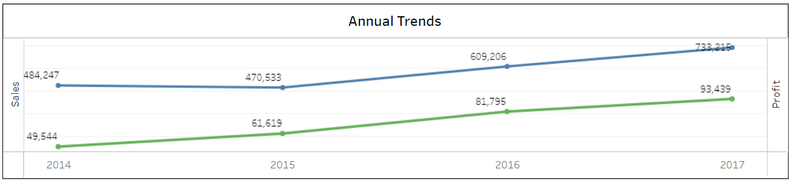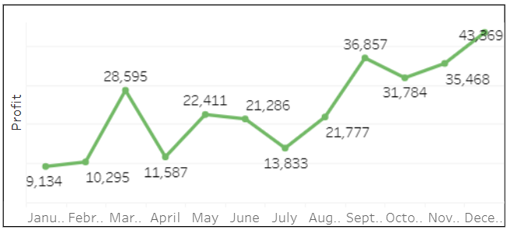

* The progression of profit earned by the supermarket is a profitability trend. An upward trend indicates that profit has grown through time, whether in the short or long term.
* We will be using 2-line charts to showcase the profit over the years. Here the profit is depicted by the Y - axis and the year/ month is represented by the X - axis.
* In the first chart we will be showing 2 lines representing the profit and sales to show the comparison between the two.
* Concerned question - What is the trend in the profit over the years?
* Pre-attentive attributes - Position will be the pre-attentive attribute

**Chart 2 - Region wise Trend of Profit**

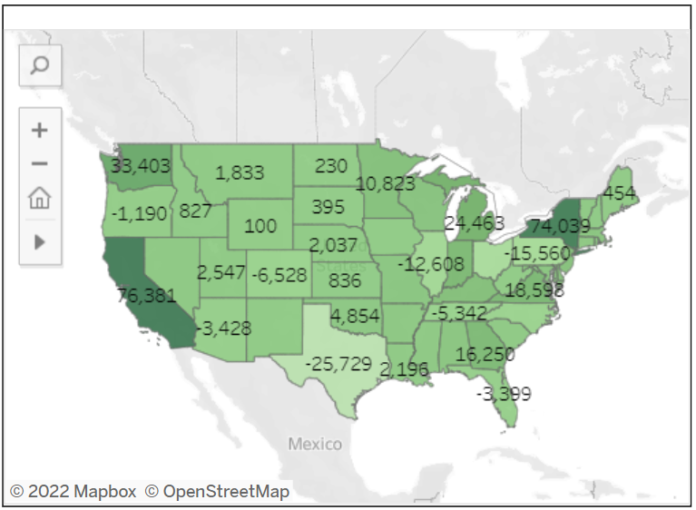

* This graph will show the profit made by the supermarket by region.
* We will be using a choropleth map to showcase the profit.
* High profit states are highlighted by the dark green color, whereas low profit states are highlighted by the green color with a lesser intensity.
* Concerned question - What is the region wise trend in the profit?
* Pre-attentive attributes - Color intensity and location will be the pre-attentive attribute

**Chart 3 - Category wise Trend of Profit**

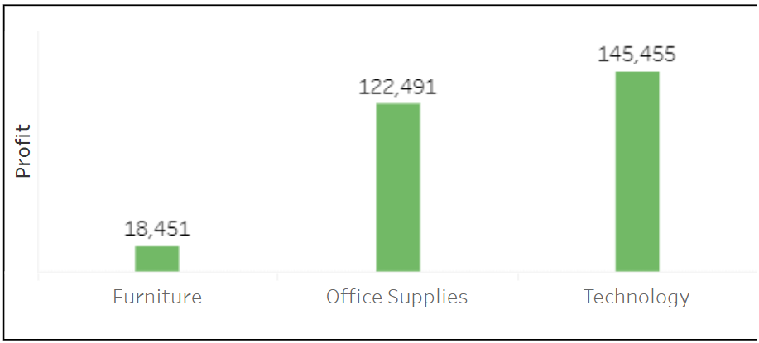

* This graph will show the profit made by the supermarket by category.
* We will be using a bar chart to showcase the profit over the years. Here the profit is depicted by the Y - axis and the Category is represented by the X - axis.
* There are three types of categories of the goods in the supermarket- furniture, Office Supplies and Technology.
* Concerned question - What is the Category wise trend in the profit?
* Pre-attentive attributes - Length will be the pre-attentive attribute.

**Chart 4 - Segment wise Trend of Profit**

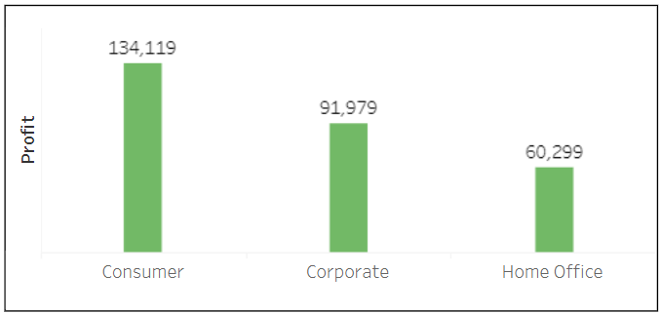

* This graph will show the profit made by the supermarket by segment.
* We will be using a bar chart to showcase the profit over the years. Here the profit is depicted by the Y - axis and the segments are represented by the X - axis.
* There are three types of segments in the supermarket: Consumer, Corporate and Home office.
* Concerned question - What is the Segment wise trend in the profit?
* Pre-attentive attributes - Length will be the pre-attentive attribute.

**Chart 5 - Best Selling Products**

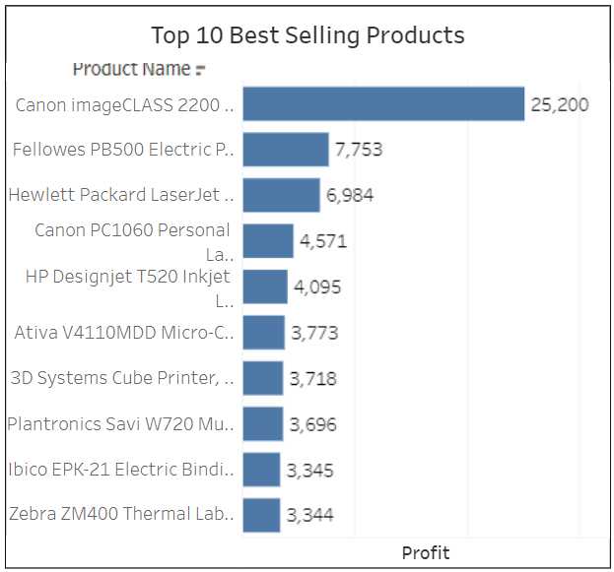

* This graph will show the top 10 best-selling products.
* We will be using a bar chart to showcase the best-selling products. Here the products are represented by the Y - axis and the sales are represented by the X - axis.
* Concerned question - Which are the top 10 Best-Selling Products of all time?
* Pre-attentive attributes - Length will be the pre-attentive attribute.

**Chart 6 - Top 10 Customers**

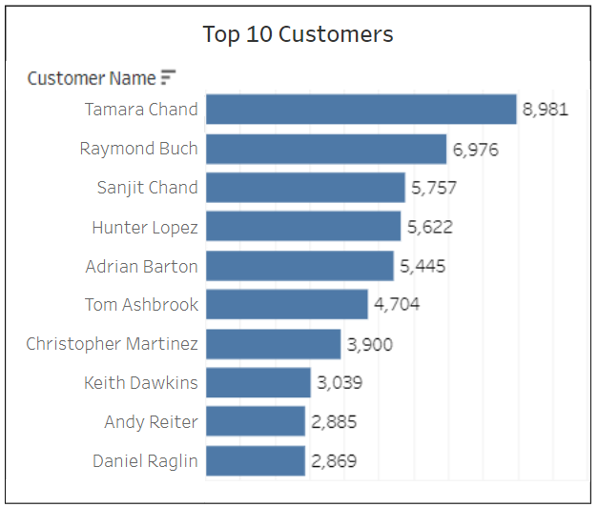

* This graph will show the top 10 best consumers in the last five years
* We will be using a Bar chart to showcase the top consumers. Here the customers are represented by the Y - axis and the sales are represented by the X - axis.
* Concerned question - Which are the top 10 customers in the last five years?
* Preattentive attributes - Length will be the pre-attentive attribute.

**Chart 7 - Least performing Products**

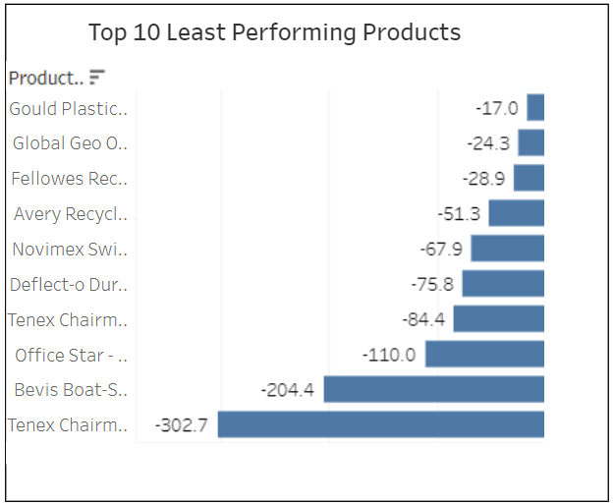

* This graph will show the top 10 least performing products based on sales.
* We will be using a bar chart. Here the products are represented by the Y - axis and the sales are represented by the X - axis.
* Concerned question - Which are the top 10 Least Performing Products of all time?
* Pre-attentive attributes - Length will be the pre-attentive attribute.

**Chart 8 - Product category wise average shipping time**

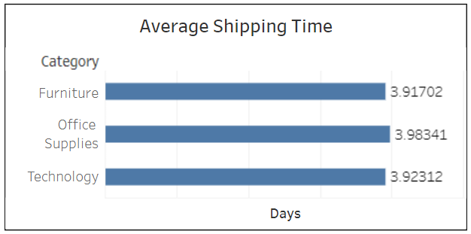

* This graph will show the average shipping time according to the product category. The shipping time is defined as the time it takes from the moment an order is validated to the time it is entirely processed and the parcel is prepared
* We will be using a bar chart. Here the product’s categories are represented by the Y - axis and the average shipping time is represented by the X - axis.
* Concerned question - What is the product category wise average shipping time.
* Pre-attentive attributes - Length will be the pre-attentive attribute

**Chart 9 - Trend in Sales over the years**



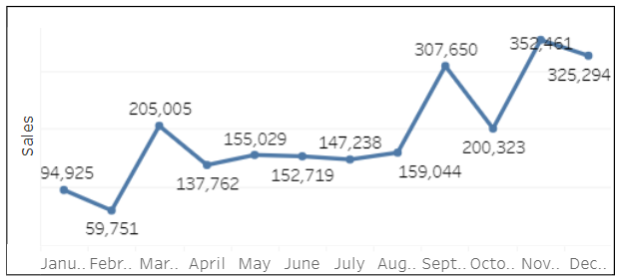

* This graph will show the sales trend over the years. The progression of sales earned by the supermarket is a sales trend.
* We will be using a Line chart to showcase the sales over the years. Here the sales are depicted by the Y - axis and the year is represented by the X - axis.
* Concerned question - What is the trend in the sales over the years?
* Pre-attentive attributes - Length will be the pre-attentive attribute.

**Chart 10 - Trend in Sales per category**

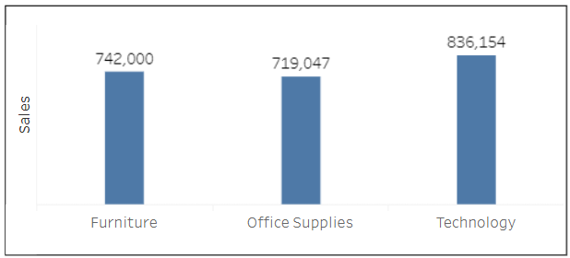

* This graph will show the sales made by the supermarket by category.
* We will be using a Bar chart to showcase the sales over the years. Here the sales are depicted by the Y - axis and the Category is represented by the X - axis.
* There are three types of categories of the goods in the supermarket: Furniture, Office Supplies and Technology.
* Concerned question - What is the Category wise trend in the sales?
* Pre-attentive attributes - Length will be the pre-attentive attribute

**Chart 11 - Trend in Sales per Region**

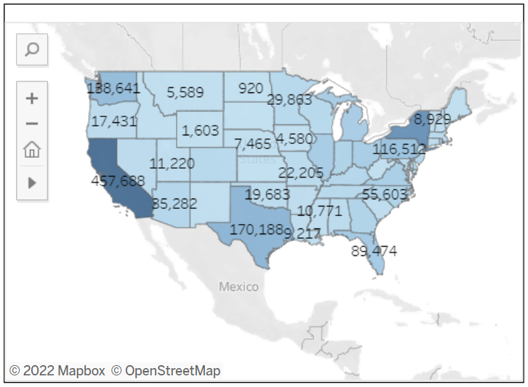

* This graph will show the sales made by the supermarket by region.
* We will be using a choropleth map to showcase the sales
* High profit states are highlighted by the dark blue color, whereas low profit states are highlighted by the blue color with a lesser intensity.
* Concerned question - What is the region wise trend in the sales?
* Pre-attentive attributes - Color intensity and location are the pre-attentive attributes

**Chart 12 - Trend in Sales per Segment**

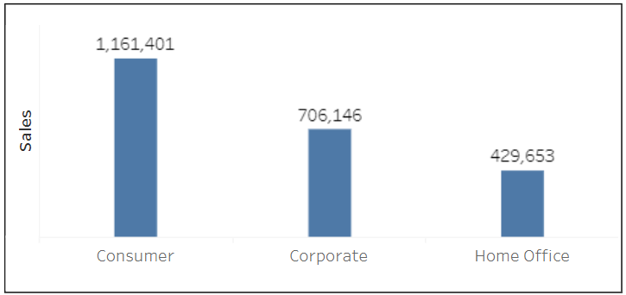

* This graph will show the sales made by the supermarket by segment.
* We will be using a Bar chart to showcase the sales over the years. Here the sales are depicted by the Y - axis and the segments are represented by the X - axis.
* There are three types of segments in the supermarket: Consumer, Corporate and Home office
* Concerned question - What is the Segment wise trend in sales?
* Pre-attentive attributes - Length will be the pre-attentive attribute.

**Dashboard Interactivity**

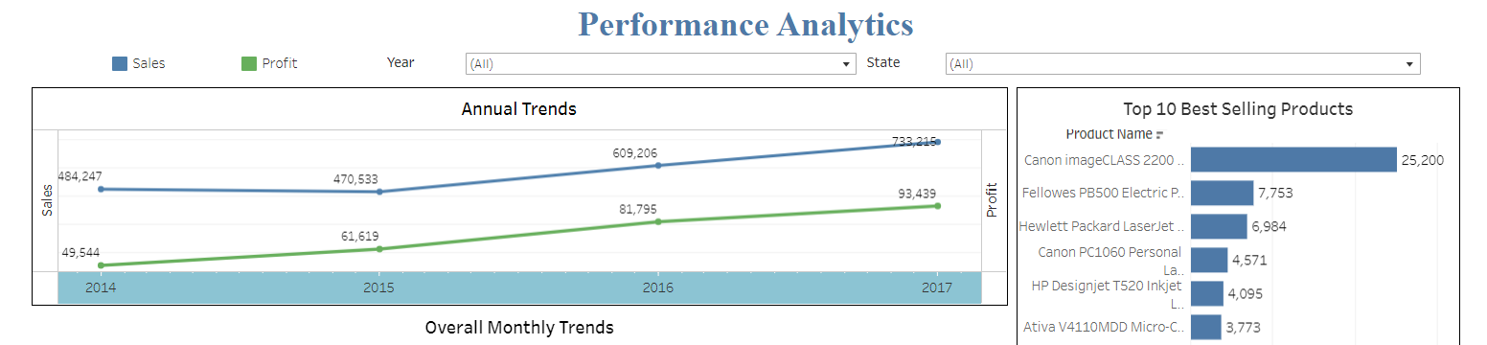

Users can apply several data viewpoints to a single dashboard using dashboard filters. Fields from the dashboard's source reports are subject to filtering criteria. A user viewing the dashboard can pick a filter to see the data of greatest interest after filters have been established.

We will be using Filters in our Dashboard for interactivity. Mentioned below are filters we will be using:

* Year Filter: This feature will filter out the values represented in the charts based on the year selected.
* State Filter: This feature will filter out the values represented in the charts based on the State selected.

**References**

* [**Dashboard Link**](https://public.tableau.com/app/profile/janak.sonalkar/viz/Group19DashboardImplementation/FinalDashboard)
* [**Mural Link**](https://app.mural.co/t/datavisualizationproject2970/m/datavisualizationproject2970/1649364159468/d139cb33db647d48d4401910f87e30bc1fece2dc?sender=uc244f1ed3d901acfcfd48548)
* [**Dataset Link**](https://www.kaggle.com/datasets/vivek468/superstore-dataset-final)
* <https://www.vendhq.com/blog/retail-dashboards/>
* <https://www.toucantoco.com/en/blog/how-to-create-a-simple-and-effective-dashboard-for-your-retail-company>
* <https://improvado.io/blog/revenue-growth-charts>
* [Retail Dashboards Explained: Why Every Merchant Should Have Them](https://www.vendhq.com/blog/retail-dashboards/)
* [How to create a simple and effective dashboard for your retail company](https://www.toucantoco.com/en/blog/how-to-create-a-simple-and-effective-dashboard-for-your-retail-company)
* [34 Charts to Spot Revenue Growth Insights in a Single Dashboard](https://improvado.io/blog/revenue-growth-charts)